[Pesamatrix]  
PRODUCT REQUIREMENTS

|  |  |
| --- | --- |
| **Target Release** | Nov 1 |
| **Product Manager** | Lawrence Chege |
| **Engineering Lead** | Antony Mwangi |
| **Designer** |  |
| **Document status/ version** | Version 1.1 |
| **Created** |  |

Problem 1

Solution 2

Use cases 2

Value Proposition 2

Goals and Success criteria 3

User experience 3

Competitor analysis 3

**Key features and releases**

User stories and requirements

**Requirements per release (optional) 4**

Out of scope 5

Questions and decision tracker 6

## Problem Statement

*Describe the problem/s being solved for your customers. Describe any internal problems being solved for your business.*

The assumption is that lending companies find it difficult to optimize their business processes while using off the shelf loan management system configurations. Most, if not all, LMS software prescribes a certain way of doing things that forces the companies using it to conform. It then becomes difficult for the Lending companies to Issue custom products with custom workflows. Adding or changing new configurations takes months for the tech companies that provide the LMS software.

*You can talk about the problem in different ways:*

* *Gaps in the existing product*
* *How it is difficult for customers/users to do certain things*
* *How business value or growth is limited or challenging*
* *Technical challenges of the product which have customer impact*

*Internal business problems solved:*

* *Process efficiency*
* *Cost savings*
* *Enabling other teams/product needs*

*Add metrics, data (qualitative and quantitative) in order to measure and quantify the problem*

*Further research and validation are required to quantify the problem and the metrics associated with it.*

## Solution

*Describe the approach and/ or capabilities/ features of the product that will solve the problems described above.*

*A mobile and desktop app that:*

* *Does this thing*
* *And this other thing*
* *In a centralised and simplified way*

*The proposed solution aims to give control of the loan products and processes to the lending company. The solution is to develop flexible and adaptable LMS software that can be adjusted to fit any lending company's processes and products.*

## 

## Use cases

*What are some of the most important ways in which a customer will use the product? What are the* [*jobs to be done*](https://jobs-to-be-done.com/jobs-to-be-done-a-framework-for-customer-needs-c883cbf61c90)*?*

*As a microfinance owner, I want to be able to automate most, if not all, of my loan lifecycle processes, this would help me cut down on labor costs.*

*As a loan officer, I want to be able to easily track all loans.*

*As a credit analyst, i want to be able to do credit analysis on the same platform as the loan process.*

*As a [user], I want to do [xyz}*

## Value Proposition

*What benefit/ value will this deliver to customers? What edge do you have over your competitors? Why would a customer choose this product?* [*Read more here*](https://www.helpscout.com/blog/value-proposition-examples/) *and download* [*Value Prop Canvas here*](https://www.slideshare.net/peterjthomson/value-proposition-canvas-28218650)

*We help [X] do [Y] by doing [Z]*

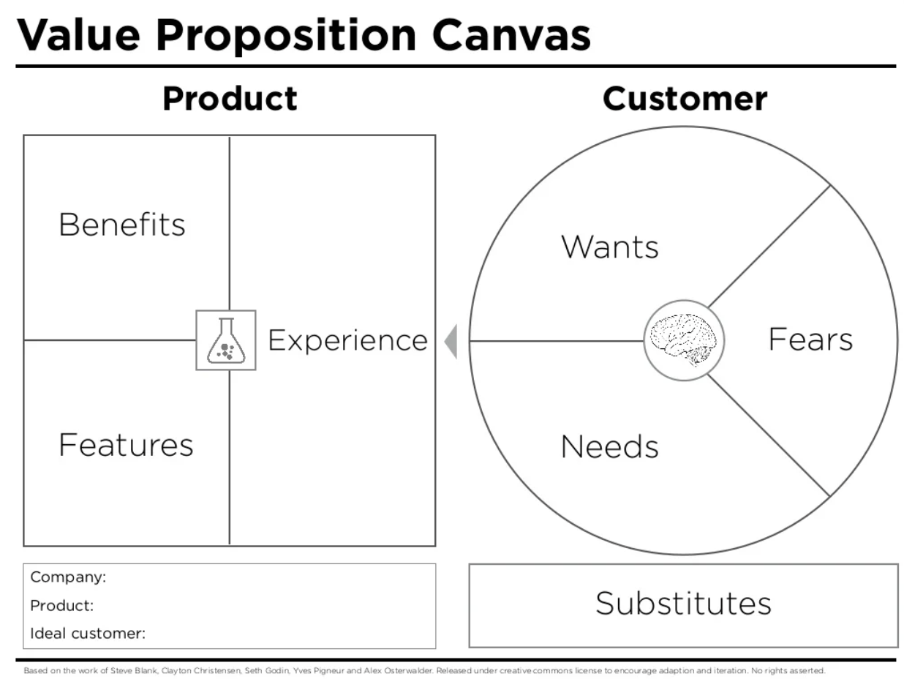

Target personas  
*Who is the ideal customer for whom you are building this product? Describe who they are and how they will benefit.*  
*Primary persona: the main customer who will benefit and for whom you are building the product.*

*Secondary persona: other customers who will benefit but are not your immediate or direct focus*

## Goals and Success criteria

*What should this product initiative achieve? What does a successful product look like? What are you aiming for? Think about your problems, and turn them into goals. I.e., problem = churn, goal = retention*

*Example: Increase customer retention by 20%*

## User experience

*How will customers discover, access, and interact with the product? Create a bullet list of the main parts of the experience.*

Designs/ flows  
*Refer to any mockups, concepts, storyboards, user journey flows, or low fidelity designs (Figma or Miro links are appropriate).*

## Competitor analysis

*Summarize key findings from the competition analysis. You can link to any detailed competitive research. Indicate how this product positions itself against the competition.*

*List competitors and an overview of their offerings as it relate to the problem you are trying to solve*

## Key features and releases

*Provide an organized list of features and how they will be broken up into different releases. Outline any phases/ versions relevant to launching the product. Think about the value proposition of each phase and how launch plans can leverage these.*

*Release phase 1*

* *Feature A*
* *Feature B*
* *Feature C*

*Release phase 2*

* *Feature D*
* *Feature E*

## User stories and requirements

|  |  |  |  |  |
| --- | --- | --- | --- | --- |
| **Feature** | **User story** | **Requirement/s** | **KPIs** | **Release** |
| 1. Installation | 1.1 As a [user], I want to easily install the [app] on my mobile device |  |  |  |
| 1.2 As a [user], I want the [app] to work across my different devices |  |  |  |
| 1.3 As a [user], I want to upgrade my app when there are new features available. |  |  |  |
| 2. Account creation | 2.1 As a [user], I want to create an account, so that I can [xyz] | - User can create account using existing social media accounts - User must set password and username  - User is sent a verification email |  |  |
| 3. Login page | 3.1 As a [user], I want to create |  |  |  |
| 3.2 |  |  |  |
| 4. Create and edit videos. |  |  |  |  |
| 5. Browse videos | 5.1 As a [user], I want to search for videos using different filters | - User can browse videos on a dedicated page (For you page)  - For you page supports keyword search and a set of filtering options  - Filtering options include: |  |  |
| 5.2 As a [user], I want videos recommended to me that meet my preferences |  |  |  |
| 6. Manage profile |  |  |  |  |
| 7. Manage Settings |  |  |  |  |
| 8. Analytics |  |  |  |  |
|  |  |  |  |  |
|  |  |  |  |  |
|  |  |  |  |  |
|  |  |  |  |  |
|  |  |  |  |  |
|  |  |  |  |  |
|  |  |  |  |  |
|  |  |  |  |  |
|  |  |  |  |  |
|  |  |  |  |  |
|  |  |  |  |  |
|  |  |  |  |  |

## 

## Requirements per release (optional)

|  |  |  |  |
| --- | --- | --- | --- |
| **Release** | **Feature** | **User Story** | **Requirement/s** |
| Release 1 |  |  |  |
|  |  |  |
|  |  |  |
| Release 2 |  |  |  |
| Release 3 |  |  |  |

## 

## Out of scope

*Be clear about the boundaries of the initiative and what is and isn’t in scope.*

## Questions and decision tracker

*Keep track of any open questions and decisions that need to be made. Some decisions have tradeoffs - document these here so people know that the discussions have happened and there is awareness of the tradeoffs.*

|  |  |  |
| --- | --- | --- |
| **Date** | **Question/ Decision** | **Answer** |
|  |  |  |
|  |  |  |
|  |  |  |